Practice Exercise #5

Fill in the blanks:

1. The ______________________________ is a system of job experience, schools, and extension courses that trains NCO's to succeed in their jobs as the advance in rank.

2. The ____________________________ is a common leader drill in which leaders go to a field site and discuss the best tactical use of terrain.

3. ________________________________allow leaders and staff elements to practice the basics of their combat missions/tasks without using their soldiers as training aids.

4. Most training and audiovisual materials will be obtained from the ________________________________.

Circle the letter of the correct answer.

5. Which of the following battle simulations could be used for a company level exercise?

a. Blockbuster

b. Pegasus

c. CAMMS II

Answers to Practice Exercise #5

1. NCOES (Noncommissioned Officer Education System)

2. TEWT (Tactical Exercise Without Troops)

3. Battle simulations

4. TASC (Training and Audiovisual Support Center)

5. a

RECOGNIZE HOW THE ARMY CONDUCTS UNIT TRAINING FOR MISSION
OBJECTIVE
6
PERFORMANCE

1. Any unit (even a staff section) is a composite of many low-level soldier teams (squads/sections/crews) directed by the chain of command, which also operates as a team. Team technical skills and teamwork will be essential in combat. Therefore, a major portion of unit training should be geared to training basic team techniques, beginning at squad level. Training exercises such as ARTEP and FTX's, which add tactical skills, will be more effective if the soldier and leader teams involved already have a certain level of proficiency in techniques.

2. Drills for many critical squad/section/crew tasks are published by service schools. During the drill, the team or crew leader trains the team. Normally, he is assisted and critiqued by the platoon sergeant or platoon leader. When a certain proficiency is obtained, the squad/section/crew team should be required to perform as a member of the platoon team. This can take place as a part of a platoon FTX or platoon drill.

3. Platoon drill, called "battle drill" in some units, consists of practice in the techniques that are common elements of platoon ARTEP missions and tasks. Used by maneuver units, these techniques include fire and maneuver, communi-cation, overwatch and other basic team skills. Training in these drills will prepare a platoon for more advanced unit training, such as platoon ARTEP exercises/ evaluations, platoon and company FTX's and so on. Training managers can develop the tasks, conditions and standards for platoon drill in their unit and make it a part of their training SOP.

4. Training devices are one feature of the Army training system that is very useful in squad/section/crew drill. Training devices are designed to support training of specific soldier's manual or ARTEP tasks. These devices are normally available through the TASC. Training managers and trainers should consult DA PAM 310-12, "Index and Description of Army Training Devices, "TRADOC PAM 71-9, "Catalog of Training Devices," and locally published TASC catalogs for those devices that are available. Training managers should become familiar with the contents of these documents before planning training activities or events. Used properly, training devices can be a great help to trainers in providing effective training to soldiers, crews or units. Therefore, training managers should know what training devices are available locally and the procedures to obtain them. "ARTEP, FTX and Other Advanced Collective Training".

5. ARTEP provides Training and Evaluation Outlines (T&EO's) that outline the tasks, conditions and standards for each unit mission. These T&EO's are excellent collective training and evaluation tools. They may be used to diagnose weaknesses or to check proficiency after training. Using the ARTEP, a unit may train at its own pace, practicing areas that need the most
attention. Trainers/leaders may Integrate as many elements of realism, to include scenario, Electronic Warfare (EW), Nuclear Biological Chemical (NBC), Opposing Forces (OPFOR) or the Multiple Integrated Laser Engagement System(MILES), as they feel the unit is ready for. As published, ARTEP's contain only a minimal scenario. This allows a unit to practice techniques while slowly adding the elements of tactics. In scenario-based collective training exercises (such as Field Training Exercises (FTX), Command Post Exercises (CPX), etc.) leaders perform their tasks together with soldier teams, usually in a very realistic field environment. Because these more realistic forms of collective training are so expensive, training managers are challenged to devise methods that will build unit proficiency at the lowest possible cost. Each exercise should be planned to fit the training needs of a specific unit at a specific time. For example, if force-on-force training is conducted, a significant number of unit assets must be dedicated for OPFOR, evaluator, controller and other support functions. The unit must be proficient enough in basic individual and lower level collective skills to receive maximum training value from such an exercise. How to plan training exercises of this type is explained in FM 25-4.

6. Training managers of maneuver units can add realism to training by planning for the use of engagement simulations. While the ultimate realism is combat itself, the Army has two aids that simulate actual warfare:

a. REALTRAIN - Soldiers wear 2-digit number badges on the front of their helmets and have 6X telescopes mounted on their weapons. Casualties occur by spotting and reporting numbers on the helmets of opposing soldiers. Vehicles are also marked and can be "killed." Controllers using radios remove "killed" soldiers and equipment from the FTX. Afterwards, both forces should meet to critique each other's perfor- mance.

b. MILES - Similar to REALTRAIN, except that eye-safe laser beams are fired from adapters on weapons. The laser beam is picked up by sensors attached to field gear and mounted on equipment. An alarm goes off when a soldier is "killed" or the equipment is "destroyed." The soldier hears a "beep" when the beam is a "near-miss." Soldiers know immediately when these things have happened. Short of actual combat, this is the most realistic training that the army can provide.
Practice Exercise #6

Fill in the blanks:

1. A major portion of unit training should be geared to training ____________
______________________________.

2. Training devices designed to support training of specific soldier's manual
or ARTEP tasks are normally available through the _______________________.

3. The Training and Evaluation Outlines of an ARTEP outline the _____________
___________________________________ for each unit mission.

4. Two training aids that simulate actual warfare are ____________________ and
_______________________________.

Answers to Practice Exercise #6

1. basic team techniques

2. TASC

3. tasks, conditions, and standards

4. REALTRAIN and MILES

RECOGNIZE HOW THE ARMY SUSTAINS MISSION/TASK PROFICIENCY
OBJECTIVE
7

1. Multiechelon training occurs when individuals, leaders and teams are trained on separate tasks at the same time. Multiechelon training is the most cost- effective way to sustain proficiency. Once a unit has attained proficiency in certain missions, it sustains that proficiency by exercising those missions at a frequency determined by the commander. If multiechelon training is conducted as a regular part of the training program, the fre- quency of practice can be reduced.

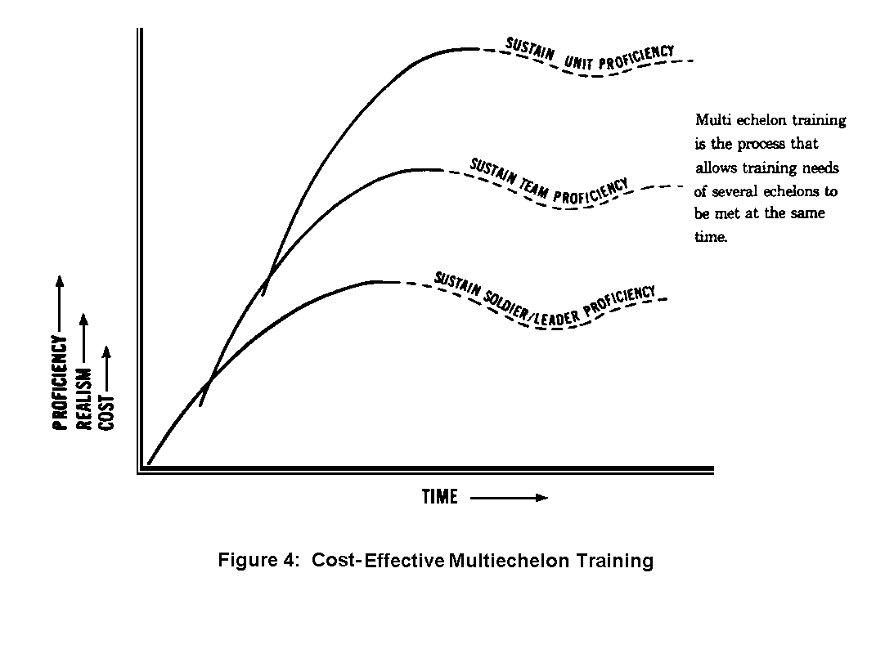
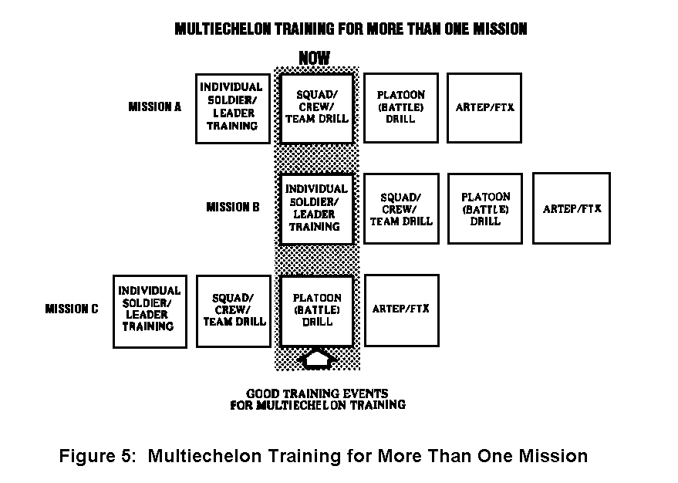

2. For example, the company commanders and platoon leaders can conduct a TEWT while crews practice crew drill. However, when a unit conducts an FTX, the whole unit practices together.

3. It takes time and know-how to develop proficient soldiers and proficient units. The training managers' challenge is to develop a training program that causes the unit to sustain proficiency, rather than allowing the unit to suffer the steep peaks and valleys of proficiency caused by cyclic training programs. Crisis management can also create those peaks and valleys in training; it can even create a desert. These subcourses on Army Training Management describe a system designed to eliminate crisis manage-ment in the unit training program

Practice Exercise #7

Fill in the blanks:

1. __________________________________ is when individuals, leaders and teams
are trained on separate tasks at the same time.

2. __________________________________ the most cost-effective way to sustain
proficiency.

3. Once a unit has attained proficiency in certain missions, it sustains that

proficiency by ___________________________________________________________

_________________________________________________________________________.

Answers to Practice Exercise #7

1. multiechelon training

2. multiechelon training

3. exercising those missions at a frequency determined by the commander

OBJECTIVE
8
DISCUSS PERSONAL/PROFESSIONAL DEVELOPMENT

1. The personal and professional development of your soldiers is another area for your review and attention.

2. Enlisted personnel now have a complete career development program tailored especially for them; the "Enlisted Personnel Management System." EPMS affects each soldier's training, evaluation, classification, assignment and promotion. As you know EPMS is broken down into five skill levels:

GRADE | SKILL LEVEL
E-1, 2, 3, & 4 | 1
E-5 | 2
E-6 | 3
E-7 | 4
E-8 and 9 | 5

3. Under the EPMS, the soldier will be evaluated, classified and promoted to the next higher grade. This concept is a significant change from the Army's previous concept: first, promote the soldier, then classify him into a higher skill level, and then evaluate him.

4. There is another supporter of professional development, "The Non-Commissioned Officer Educational System." NCOES is classroom instruction combined with on-the-job training to provide NCO's with job related training throughout their careers. The major objectives of NCOES are:

a. To train soldiers in the techniques and methods required to train their subordinates on the job.

b. Increase the professional quality of the NCO corps.

c. Provide the Army with highly trained and dedicated NCO's to fill positions of increasing responsibility.

d. Insure that soldiers receive the necessary training to perform in the
key duty positions at the next higher grade.

e. Increase career attractiveness by providing a system of formal military training.

f. Provide enlisted personnel with opportunities for continuous and progressive personal and professional developmen
This page intentionally left blank.
Practice Exercise #8

Circle the letter of the correct answer.

1. Under the EPMS, the soldier is:

a. promoted, classified, and then evaluated

b. evaluated, classified, and then promoted

c. classified, promoted, and then evaluated

Fill in the blanks:

2. ___________ is classroom instruction combined with on-the-job training to provide NCO's with job related training throughout their careers.

3. What professional career development program gives all enlisted personnel
a complete and career incentive oriented program?
____________________

Answers to Practice Exercise #8

1. b

2. NCOES

3. EPMS

Lesson #2 Self-Test

Circle the letter of each correct answer.

1. In performance-oriented training, the soldiers are required to practice
until:

a. they can perform to standard

b. the training session is over

c. they are required to move on to the next step

2. For most Army training, what is the most critical phase of training?

a. preparation

b. presentation

c. practice

3. The _________________________ is used to evaluate soldiers' ability to
perform under specified conditions to the stated standard.

a. five part process

b. training objective

c. critical event

4. What is the best method to get soldiers to retain skills?

a. regular exercise refreshing skills

b. periodic presentations by the commander

c. off-duty reading of training materials

5. When can the element of tactics be added to training?

a. at the very beginning of training

b. only when a major exercise is scheduled

c. once techniques are mastered

6. Centralizing individual training should be considered:

a. only for very low-denisty MOS's

b. whenever possible

c. only for high-density MOS's

7. The standard reference for the performance of individual tasks in any MOS at any level is:

a. the Trainer's Guide

b. the soldier's manual

c. the commander's guidance

8. This is the Army's ongoing program for completing a soldier's individual
training or retraining him into a new critical-shortage MOS career field.

a. SOJT

b. BSEP

c. ACCP

9. This program offers almost every course taught in Army schools. Soldiers
may take these courses on their own time.

a. SOJT

b. BSEP

c. ACCP

10. This is a common leader drill in which leaders go to a field site and
discuss the best tactical use of terrain.

a. NCOES

b. TEWT

c. TASC

11. Most training and audiovisual materials will be obtained from the:

a. NCOES

b. TEWT

c. TASC

12. For each unit mission, the Training and Evaluation Outlines of an ARTEP
outline all but which of the following?

a. equipment needed

b. tasks

c. conditions

d. standards

13. Individuals, leaders and teams are trained on separate tasks at the same
time in:

a. multiechelon training

b. cross training

c. field training

14. Under the EPMS, the soldier is:

a. promoted, classified, and then evaluated

b. evaluated, classified, and then promoted

c. classified, promoted, and then evaluated

Lesson #2 Self-Test Answers

1. a
If you got this wrong, go back to page 39 and review.

2. c
If you got this wrong, go back to page 40 and review.

3 b
If you got this wrong, go back to page 40 and review.

4. a
If you got this wrong, go back to page 42 and review.

5. c
If you got this wrong, go back to page 48 and review.

6. a
If you got this wrong, go back to page 53 and review.

7. b
If you got this wrong, go back to page 53 and review.

8. a
If you got this wrong, go back to page 54 and review.

9. c
If you got this wrong, go back to page 55 and review.

10. b
If you got this wrong, go back to page 59 and review.

11. c
If you got this wrong, go back to page 61 and review.

12. a
If you got this wrong, go back to page 65 and review.

13. a
If you got this wrong, go back to page 69 and review.

14. b
If you got this wrong, go back to page 73 and review.

